Greetings to All of us!! Admission opens at;

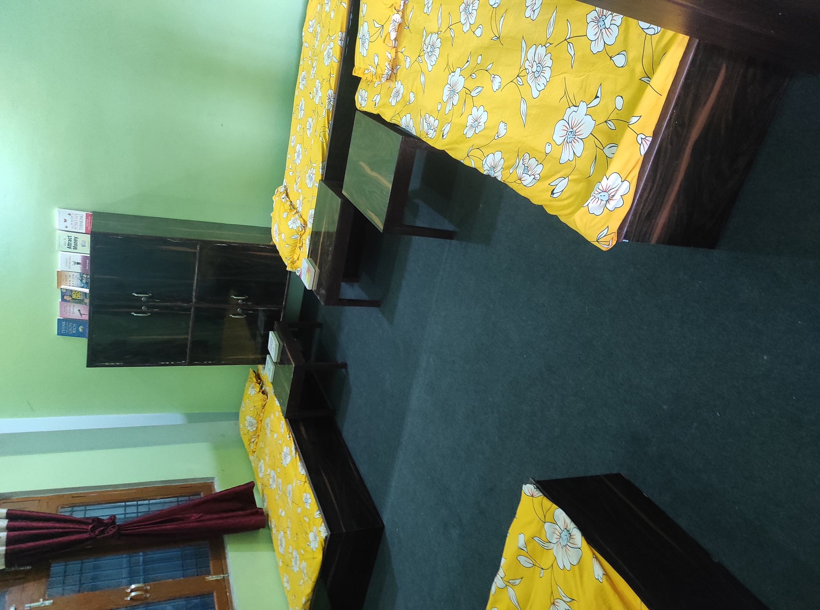 Power House Boys Hostel

Birgunj-13, Parsa (near St. Xavier College)

Power House Boys Hostel has been established with a motto to provide you the best facilities in Birgunj. We believe that it’s the right time to invest on yourselves. Well it’s time to be true to yourself and take the right decisions to achieve your goals. And we have come up with a great solution to help you achieve your future objectives with these **Facilities:**

# ●Comfortable Accomodation

● Hygienic food

ALL At Just Rs.300 per day

●High Speed INTERNET

● free Laundry

●Hot and cold water

●Parking space

●Free international bestseller books

For more details contact or message at: 9865160413

9803529240(Watsapp)